Practical Electronics For Inventors Notes
Christopher Kalitin

PDF: https://mlp6.pages.oit.duke.edu/MedTech-Prototyping-Skills/Practical_Electronics_for_Inventors_Fourth_Edition_By_Paul_Scherz_and_Simon_Monk.pdf

2.4: A Microscopic View Of Conduction (for Those Who Are Interested)

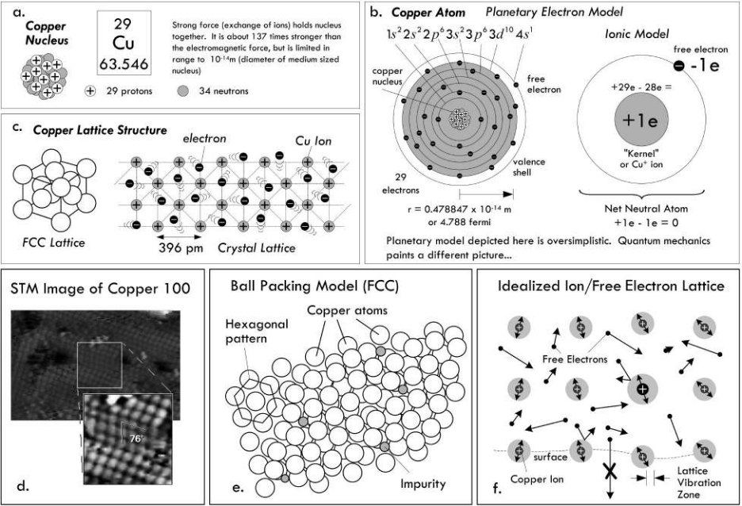

Face-centered-cubic lattice structure of copper atoms in a conductor.

Metallic bonding is where the outermost valence electrons form a “cloud of free electrons” which fill space between metal ions. The free electrons hold the lattice of metal ions together, somehow.

The strong force (exchange of ions?) holds nuclei together, 137x stronger than electromagnetic force but falls off faster.

~400 pico meters between copper atoms in a crystal lattice (equivalent to face-centered cubic).

Copper atoms have a diameter of ~0.25 nm, 0.396 nm between team is a little more than a single atom.

Scanning Tunneling Electron Microscope = STM

At room temp and nominal conditions, no electrons can overcome the coulomb (electric) force and escape the conductor.

The Free Electron Model treats free electrons as not interacting with 1 free electron per copper atom. Under normal conditions, the thermal velocity of electrons within copper is 120 km/s and they move 2.9e-9 m between colliders (2.9nm=).

Quantum mechanics sees free electron velocity (Fermi velocity) as 1.57e6 m/s (1 Mm/s), and independent of temperature. Also, 39nm mean free path (~15 copper radii).

It various with element too:
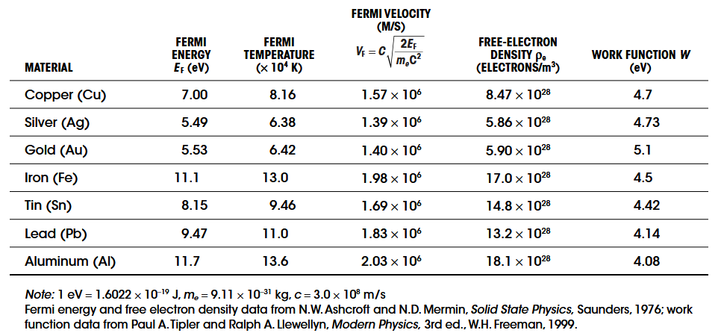

Surface binding energy is what prevents electrons exiting the surface of the metal. Work function.

Thermonic emissions: increasing temperature until free electrons have enough energy to overcome work function of the material.
Field emission: emitting electrons through electric fields generated by high-voltage conductors. Megavolts per cm.
Secondary emission: bombard the surface with high-speed electrons or other particles, get some electrons out.
Photoelectric emission: electrons absorb incoming photons of particular frequency, then release themselves. W = hf₀, h is Planck’s constant.

2.4.1: Applying a Voltage

When attaching a battery to a conductor, electrons are pumped in at one end and the other end is neutral (relative). Force on all electrons in the conductor.

This force is tiny compared to thermal velocity (or fermi velocity), so you get slightly parabolic paths:
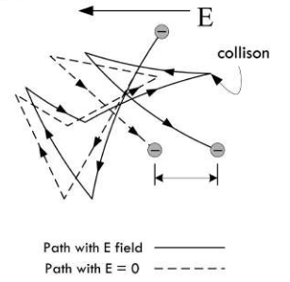

$V_{d}=\frac{J}{p_{e}e}$
J = current density (area)
p_{e} = free-electron density
E = charge of electron

When a voltage is applied, electrons exert forces on their neighbours at near-lightspeed.

Eg. when you turn on a garden hose, outflow will start immediately if it’s already full of water.

It doesn’t take an electron - with V_{d} of mm/s - moving to the other end of a wire to transfer energy. It takes electromagnetic forces between electrons to transfer energy.

Now we have:
- Drift velocity
- Fermi/Thermal velocity
- Signal velocity

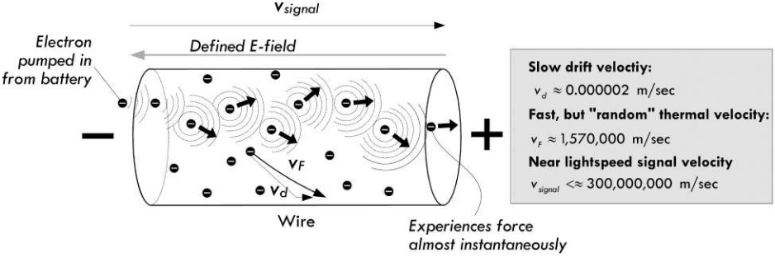

2.13: Voltage and Current Sources
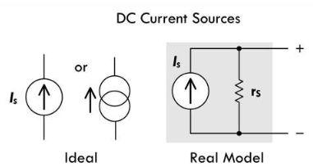

Because of the internal resistance of a voltage source, when a load is connected it acts as a voltage divider.

This is why for low load resistance values relative to the internal resistance, the terminal voltage drop significantly.

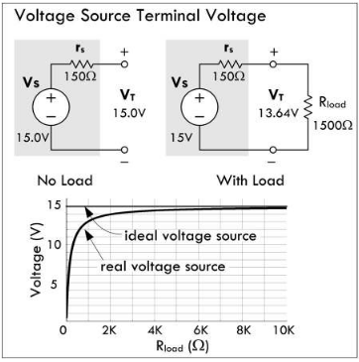

A current source modulates terminal voltage such that source current is constant.

Real world current sources have large internal shunt (parallel) resistances.

Shunt = parallel

https://chatgpt.com/c/68507ec3-3150-8006-b6a3-27a4c5ce2555
A current sense shunt is in series with the load.

A meter-movement shunt is in parallel with a delicate galvanometer movement so that less current goes through the delicate component. Huh?

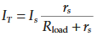

When R_{load} approaches r_{s} you get a dip in current since it’s a parallel resistor circuit.

An ideal current source has infinite internal resistance.

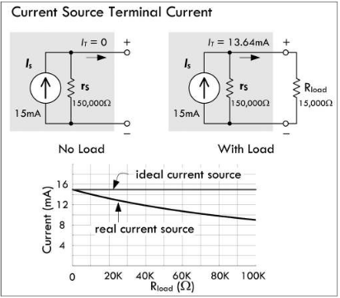

A practical current source is an active circuit made of transistors (remember these are current controlled).

Vin goes to the base of Transistor 2 and enables it. R2 serves to create a voltage difference that if it gets too high enabled Transistor 1 and robs the second transistor of base current, lowering current. I think? No transistors are current controlled devices so what’s the R2 resistor fow?

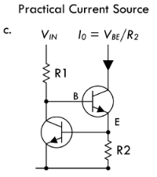

2.22: Mains Power

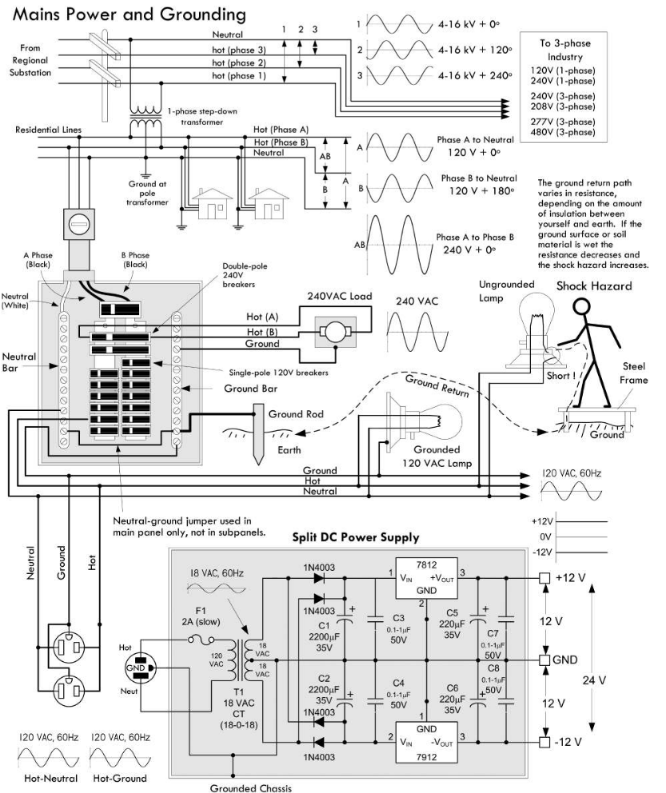

The 1-phase step-down transformer from the 4-16 kV lines to the 120 V residential lines has 3 outputs, Hot Phase A, Hot Phase B, Neutral.

Neutral is tapped into the middle of the transformer inductor so it is exactly between both hot phases. This also means that the AC voltage of Phase A and Phase B is exactly 180 degrees offset from each other.

Hence, V_{AB} = 240 V, V_{A} = V_{B} = 120 V

These voltages can vary in reality to ~117V. +/- 3.

These wires are connected through a watt meter t oa main service panel that’s grounded to a long copper rod driven into the ground or a steel home foundation.

There’s a main disconnect breaker for Phase A and Phase B.

Conduit = wire casing

In the main service panel neutral and ground are shorted. Not in subpanels though.

Most subpanels get ground from the main panel through the metal conduit (wire casing). In some critical applications like computer or life-support systems the ground wire is included in the conduit.

If the subpanel is not in the same building as the main panel, there’s usually another ground rod.

This is all dependent on local regulations.

Two bus bars in the main service panel into which circuit breaker modules are inserted. A phase bus and B phase bus.

Choosing which bus bar to put a new breaker in only has to do with balancing the overall load.

Ground wires are typically fastened to the case of the load.

240 V loads are supplied by a wire between phase A and phase B.

Ground wires are either green or bare.

Ground path has resistance too. When wet there’s lower resistance.

ChatGPT Questions:
https://chatgpt.com/c/68507ec3-3150-8006-b6a3-27a4c5ce2555

1. To 3-phase industry voltages explanation:

120 V / 240V split phase (1 phase) with a center tapped winding.
This is residential voltage with two equal 120V halves 180 degrees apart.

120/208 V 4-wire wye

Line to neutral: 120V
Line-to-Line 120V * sqrt(3) = 208 V

A wye is network is 3 loads in parallel. It’s the geometry of this 3-phase 120 degree system that gets you the multiplication of sqrt(3).

This is wired to small commercial buildings and apartment blocks.
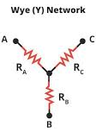

240 V delta

This is 3 wires in a delta configuration
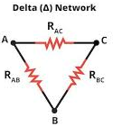

Any two lines are 240 V. Goes to older machine shops and some farms

277/480 V 4-wire wye

Line-to-neutral: 277 V
Line-to-line: 277 V * sqrt(3) = 480 V

More that I don’t understand, phasor geometry.

2.
Different primary phases are fed into residential transformers so that the utility has a balanced load.

3. How to get 180 degree phase difference from a single AC line

The transformer secondary looks like this:
----120 V----N----120 V----
“Hot A” “Hot B”

V_{A} = +120sin(wt)
V_{B} = - 120sin(wt + phi)

Because the sign is minus, you get a 180 degree phase shift! Wow!

With an neutral in the middle, both ends are opposite each other and you get a perfect 180 degree phase shift.

Center Tap is connected to ground

4. By neutral to ground only at main service panel?

Neutral carried load current.

The grounding conductor should never be a normal return path, it’s a fault path.

If neutral and ground are rebonded downstream, there are parallel current paths. Neutral current could then flow through the conduit, water pipes, etc. and this defeats GFCI.

Subpanels get 4 wires: Hot A, Hot B, Neutral, Ground.
5. How does ground protect you?

Eg. toaster chassis is positive. If you touch that and your faucet you are the lowest resistance path and you die.

If the chassis is ground (tied to neutral at the service panel), when hot shorts to chassis there’s an extremely low-impedance path back to the source.
Hundreds of amps momentarily, but breaker/fuse trips. GFCI is a second layer of protection here since it trips where hot and neutral current difference exceeds ~5mA.
Ground is not a magical sink that absorbs electricity. It is a low-resistance return path that forces a fault to create enough current to open a proactive device.

6. “From regional substation” wires

Transmission lines = 69-756 kV on tall lattice towers for long distance transmission.

Primary-distribution (medium voltage) feeders are the wires on neighbourhood streets.
4-35 kV. They run a few kilometers before feeding pole or pad mounted step-down transformers. Feeders.

Secondary conductors (120/240 V lines from pole to house.

“From regional substation” wires are primary-distribution feeders.

7. If neutral and ground are bonded in the main panel why isn’t load current through to Earth ground?

Current follows the complete circuit back to its source. The source is the center tap of the transformer secondary on the pole.

The grounding electrode path is much higher impedance than the wire toe the center tap. 10s-100s of ohms.

Negligible current trickle flows through the ground rod.

The ground electrode is required for lightning, surges, and reference stability, not for carrying current.
Electrical codes limit its duty cycle to fault or surge events only.
8. Why do extra neutral-to-ground bonds downstream defeat a GFCI

How a GFCI works:
- Hot and neutral pass together through a miniature current transformer (CT)
- Normally, I_{Hot} = I_{neutral}, magnetic fields cancel and flux = 0
- If > 5mA difference, and current transformer output rises and an internal circuit opens both how and neutral contacts in 20-30 ms.

What goes wrong with multiple neutral-ground bonds:
- You create a parallel return path to the transformer center tap
- Some neutral current flows back on the grounding conductor, which is outside teh GFCI’s GT window
- The CT would see an imbalance between neutral and positive, causing it to trip for no fault

9. How AC transfers energy

It’s a wave, electrons go back and forth and move extremely little (a couple hundred diameters of a copper atom per cycle.

The electric and magnetic field and Poynting vector carry the energy.

Poynting vector = 1/u * E cross B

Electric field motion carries the power? Yea it’s all fields. Still need to learn more here.

2.23: Capacitors

Remember Protons don’t move!
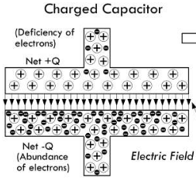

2.23.14: Capacitive Divider

For AC currents, capacitive dividers exist. Impedance is proportional to frequency. X = 1/wC

It differs from a voltage divider in that C₁ and C₂ are swapped. Now the first capacitor is on top instead of the second resistor.

Output voltage is independent of input frequency.

Low reactance means low current capability here?
“If the reactance of the capacitors is not large at the frequency of interest (i.e., the capacitance is not large enough), the output current capability will be very low.”
Chat says misprint
https://chatgpt.com/c/6850712b-6150-8006-8fac-bf0a172703c6

Corrected: If reactance is a large at the frequency of interest, output current capability will be very low. So it matters how you select you voltage/capacitor divider component values for the output current you want.
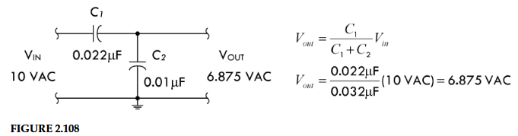

2.23.15: Quality Factor
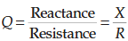

Ratio of ability to store energy to sum total of all energy losses.

Most capacitors have Q>1200

Microwave capacitors can have Q <= 10 at 10 GHz or higher

2.24: Inductors

2.24.8: Inductor Cores

Inductor magnetic cores are either laminated iron or a molded mix of iron powder or ferrite material. This increase flux density.

The magnetic field of the outer coil causes atomic rearrangement of magnetic dipoles within the core material.

More current = more common direction dipoles.

This means the core itself generates a magnetic field. The net magnetic field is the the sum of the coil and core. It’s proportional to the external field (coil) and a term proportional to the magnetization M of the core itself.

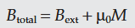

External + core fields!

Mue = permeability of free space.

Magnetic intensity due to real current in the coil = H
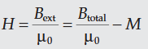

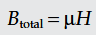

Total magnetic field equals permeability of core material times magnetic intensity due to coil current.

This is why a good core material is so important, magnetic field is directly proportional to the permeability of it.

Relative permeability = ratio of magnetic flux density by a given core material over flux density of an air core:

Ie. ratio of improvement over air

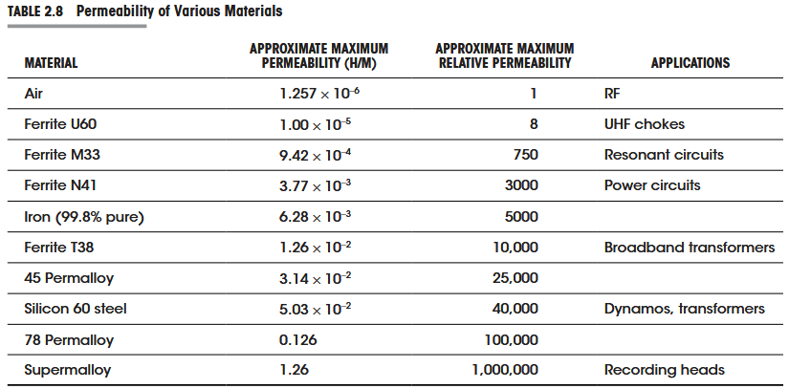

Conductive magnetic core materials get eddy currents when changing magnetic fields are applied.

Eddy currents are literally current, thus cause resistive losses. They are higher in materials with low resistivity.

To avoid eddy currents, laminate layers of conductive core materials between insulating sheets of varnish or shellac.

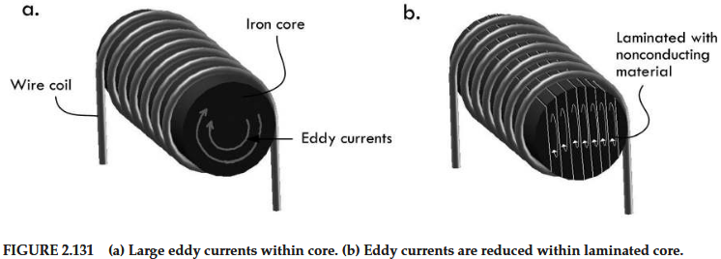

Steel is 1000 Ohms per cm for Mn-Zn ferrites
Steel is 10,000 to 1,000,000 Ohms per cm for Ni-Zn ferrite.

Eddy current losses are less of a problem in ferrites which is why they’re used in higher-frequency applications.

Ferrites:
Ferrites = class of ceramic materials with magnetic properties.

Ceramic = inorganic, non-metallic solid

Ceramics are created by heating raw materials (oxides, nitrides, carbides) to high temperatures then cooling them to form a hard, brittle materials with high melting points, electrical insulation, and chemical resistance.

Eg. clay pottery, porcelain, glass, bricks, and technical ceramics like alumina and ferrites.

Ferrites are ceramics because they are made from metal oxides (Fe2O3, ZnO, MnO), formed through sintering (powder pressed and based at 1000-1400 C)

Iron’s permeability is not constant, varies with strength of the magnetic field and temperature.
At very high magnetic fields, the core saturates and relative permeability drops to a value near unity (1).
Also dependent on past history of current in the winding (remanence). This is essential to permanent magnets but in inductors gives hysteresis losses.

Permanent magnetics have internal microstructures that keep alignment after the magnetic field is gone. Soft iron saturates at ~1.6 - 2 T, so it’s easy to write and erase.
HDDs and MRAM works on this principle. The write head of an HDD is a tiny electromagnet driven by a +/- current pulse. They keep flux when powered off until the next rewrite. Permanent magnets keep flux for decades.

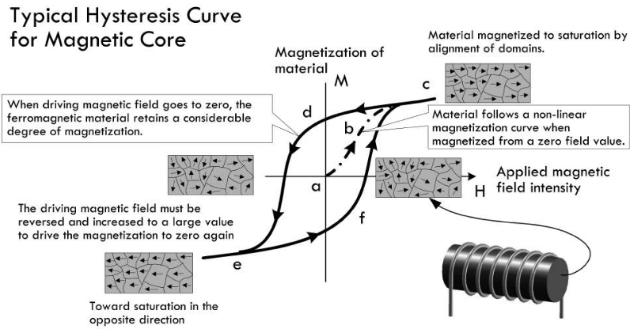

Point a: no current unmagnetized
From a->b->c current increases (H) and magnetization increases until saturation (diminishing returns).
Notice that as H is decreased, at point d magnetization is still positive. A different path is followed.
Air, brass, aluminum cores with permeability of 1 are immune to hysteresis effects and losses.

Hysteresis = history-dependence. Present output of a system is also determined by the path taken to the current state.

When H ramps up and back down, B does not follow the same line. Magnetic hysteresis meaning the previous states determine the current state and future path.

It’s all about microscopic particles in the permanent magnet and how they move. Picture it?

I think hysteresis losses are the work associated with moving on the M-H curve or B-H curve. W = HB (B is magnetic field)

Eddy currents and hysteresis losses can build up so much that an inductor acts like a resistor. The coils can also act like a capacitor.

Eddy currents and hysteresis losses in iron cores increase rapidly as frequency of ac increases. Used in power supplies. Highly prone to eddy currents since it’s conductive.

Powdered iron cores mixed with a binder or insulating material reduce eddy currents. Iron particles are insulated from one another so less conduction but the dipoles still align!

Ferrites are non-conductors and immune to eddy currents. Used in RF choke and wideband transformers (wideband = pass a frequency band of several decades) (decade = 10x increase in frequency).

2.24.19: Nonideal Inductor Model

Real inductors are modelled with R_{DC}, C_{p}, R_{p}.

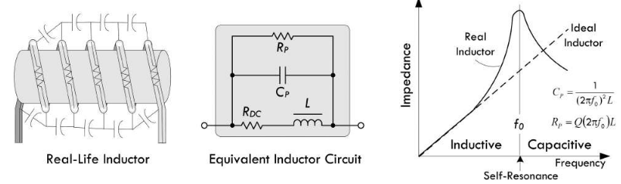

R_{p} is magnetic core losses and is derived from the self-resonant frequency f₀.

At the self-resonant frequency the reactance of the inductor is zero, the impedance is purely resistive.

Above resonance, the reactance is capacitive and decreases with frequency. (See the peak).

2.24.20: Quality Factor

Q = X/R
X = capacitive or inductive reactance
R = sum of all resistances

For inductors:
Q = wL/R_{DC}

Inductor Q’s usually never approach capacitor Q’s.

Inductive divider formula assuming no mutual inductance:
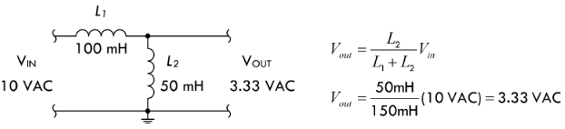

L₂ is the shunt element.

2.30: Resonant Circuits

2.30.1: Resonance in RLC Circuits

2.30.2: Q (Quality Factor) and Bandwidth

2.30.3: Bandwidth

2.30.4: Voltage Drop Across Components in RLC Resonant Circuit

2.30.5: Capacitor Losses

2.30.6: Parallel-Resonant Circuits

2.30.7: The Q of Loaded Circuits

2.32: Input and Output Impedance

2.32.1: Input Impedance

It’s called input impedance, because reactive components like capacitors and inductors make it frequency dependent. At low frequencies (eg. <1000 Hz), you can call it input resistance.

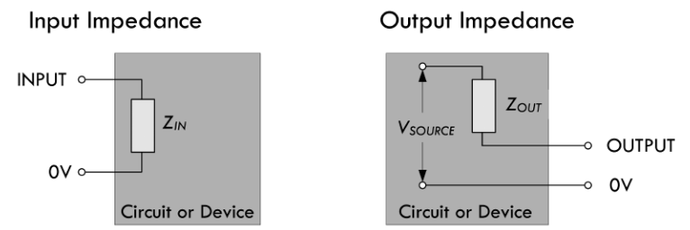

Input impedance produces a voltage drop. Low input impedance means high current can be drawn. This is the impedance ratings on speakers (eg. 4, 6, 8 ohms).

Op amps have extremely high input impedance (mega ohms), so one of the inputs will draw nano-amps.

Output impedance of a circuit supplying signal to a device should be 10x higher than that device’s input impedance.

2.32.2: Output Impedance

Input / Output impedance is all about voltage drop.

2.33: Two-Port Networks and Filters

2.37: SPICE

2.37.1: How SPICE Works

2.37.2: Limitations of SPICE and Other Simulators

2.37.3: A Simple Simulation Example

3.1: Wires, Cables, and Connectors

3.1.5: High-Frequency NEffects Within Wires and Cables

https://x.com/observie/status/1948557408437240155/photo/1
CAN Termination!

Try building this:
https://x.com/jwt0625/status/1844621000098697645/video/1

